**Quick PC**

*PC Building Assistance Mobile Application*



**Design Specification Documentation**

CECS 491A T/TH 12:30 PM

# **Table of Contents**

**Table of Contents** **1**

**Abstract** **2**

**Behavior Specification** **3**

Feature #1: Search for parts with prices, features, etc 3

Feature #2: View Component Comparison 4

Feature #3: Create PC Build 5

Feature #4: Suggest Build 6

Feature #5: PC Information Page 7

**Architecture Specification** **8**

Class Diagram 8

Site Map 9

# 

# 

# 

# 

# 

# 

# 

# 

# **Abstract**

The purpose of this document is to describe the design and architecture for our mobile application called QuickPC. The main focus of our mobile application is to provide an easy introduction to PC building and help users learn more about PC assembly. The target audience for our application are those that are not knowledgeable about PC components and have a desire to learn more about the process of building a computer. Our Design Specifications document consists of graphical representation of our applications. In our documentation, we focused on five major features that are crucial to the success of our application. Five major features we focused on were the ability to search for parts, view component comparison, create PC build, suggest build, and PC information page. By implementing these features, we allow users to be able to accurately design their computer builds. An important feature of our application is that the prices of PC parts should be accurate and recent.

The purpose of this document is to get a visual representation of how our features and application works. We designed our behavior specification based on the use cases we made in our previous documentation. As for our architecture specification we included class diagrams that helped our stakeholders get an understanding of the structure of our application. Next, we implemented a site map that helps map our interactions and relationships in our application.

# **Behavior Specification**

## Feature #1: Search for parts with prices, features, etc

After a user opens the application and logs in to the program, they can choose to edit a list of parts for a particular computer setup. They will be taken to a list of different components for each computer part, and they have the option to choose which PC part they want to search for next to a list element. When the user decides they want to search for a computer component, a basic SQL query is set up to retrieve all parts that fall under the requested PC category. Those results are populated to a list, in which a user can choose an element from that list and view its information. If the user chooses to filter results or sort by price, a new query can be used to find parts and sort by price or other specific conditions rather than use a sort algorithm to sort the list.

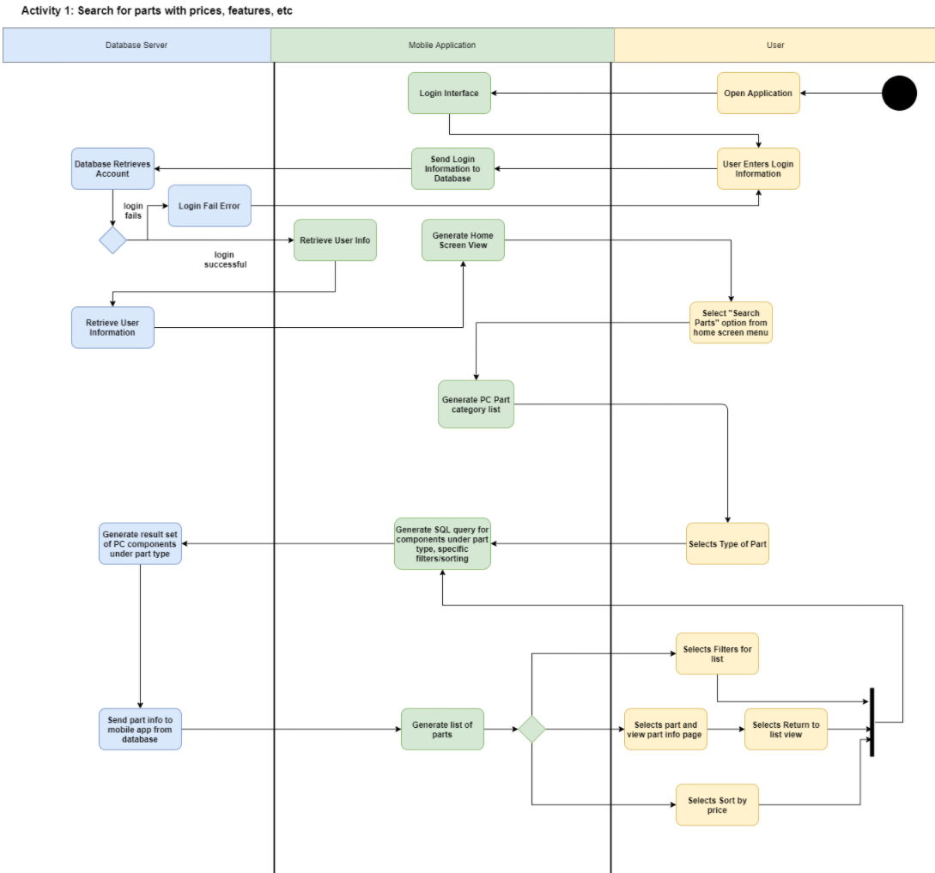

## Feature #2: View Component Comparison

In our view component comparison feature, we allow users to choose parts to compare their specifications in order to check which one is better than the other. Once the user logs into their account, the user selects “Search Parts” and the mobile application will then generate a list of PC components. The user will then select the specific component and the application will then generate a list of parts. The user would then be allowed to choose 2 parts to compare their specification. If “compare parts” is chosen, the application will generate an SQL query to obtain all the parts specifications from our database and then generate a comparison view of the two parts.

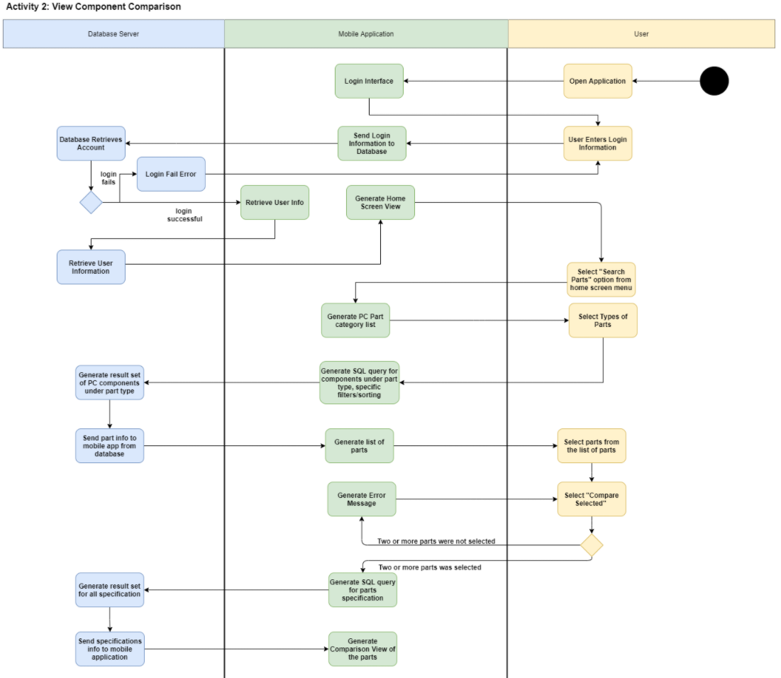

## Feature #3: Create PC Build

Once in the Home screen the user has the option to select “Build PC”. This page displays a list of the parts that a pc can have, along with the total budget of the parts. The user can select a part and get taken to the search page for that specific type of part. The list of parts of that type is retrieved from the database. If there are already parts on the list then only compatible parts are added to the search list. The user can add a specific part to the list or view the info page on a part and then add it. The total budget is recalculated as parts are added. The user can save the pc build list to their account for later use or edits.

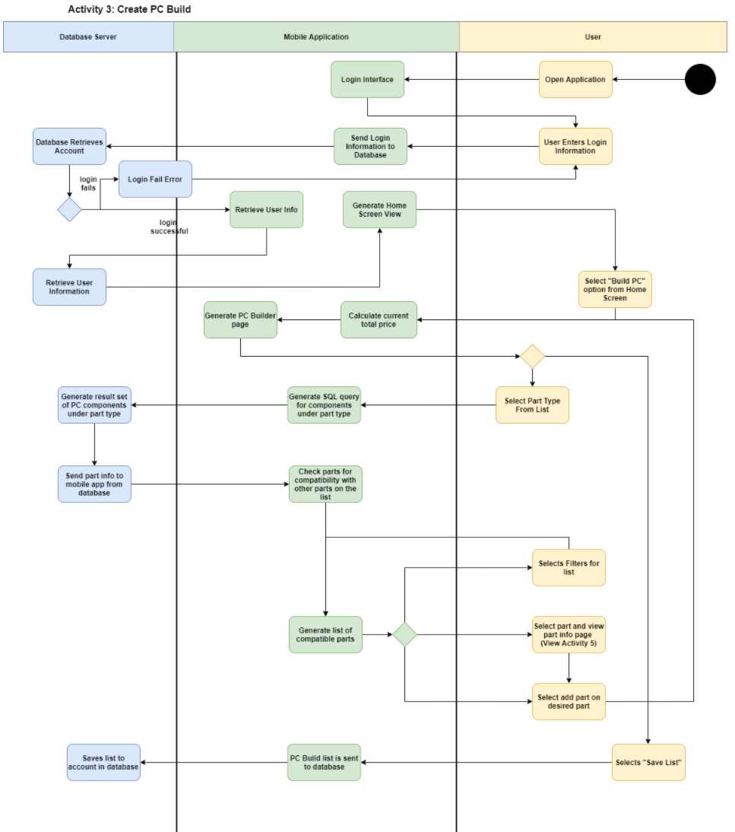

## Feature #4: Suggest Build

The “Suggest Build” page provides users with the ability to personalize and tailor their computer build requirements and needs. Immediately after selecting the “Suggest Build” tab, the user is prompted with 2 personalization options. Option 1 asks the user to input their budget range. Option 2 displays a drop down menu that offers a list of build path standards. These build paths include: gaming pc, workstation, streaming pc, and mining pc. Once the users completes both options a list of recommended builds is generated and retrieved from the database. The generated list of recommended builds is then displayed to the users. Finally, the user can either sort by price, add to their “save list”, or proceed to add the prebuilt components to their PC Part builder list.

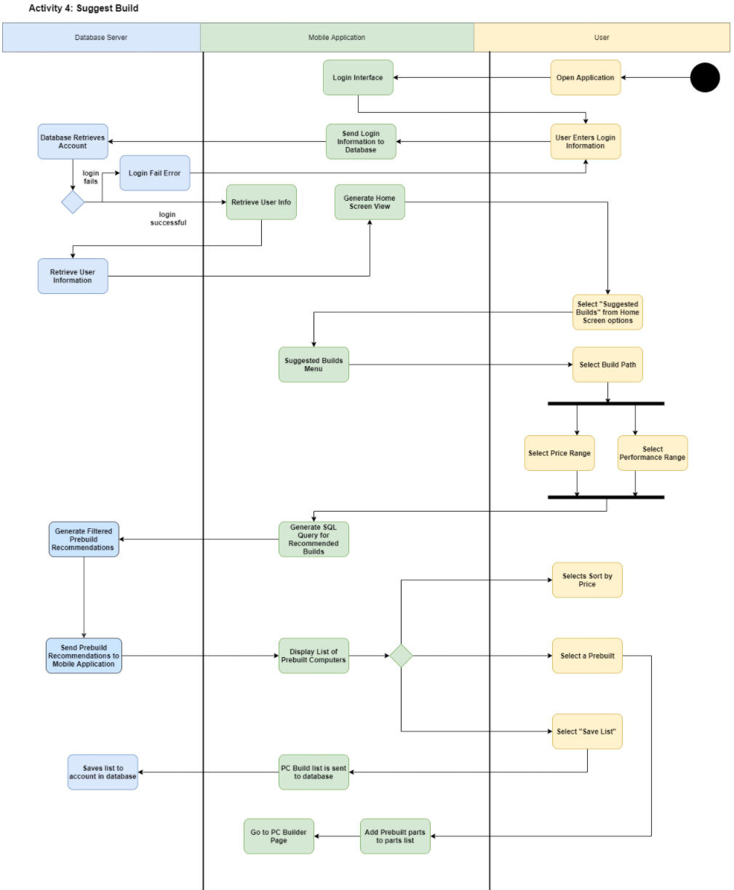

## Feature #5: PC Information Page

Users will be able to view a PC information page and from that page they can add the part to a list, open a store page for the part, write a review about the part, and sign up for a product alert for the PC part. The user first logs into their account and then chooses to select a part type. Once the user has specified the part they are looking for the app generates a list of parts from the database that matches what the user had specified. From there a user can select the PC information page from a list of parts. On the PC information page a user has the option to write a review in a textbox and give the part a star rating. Once the user has finished their review and published it the database updates the PC information page to display the new review.

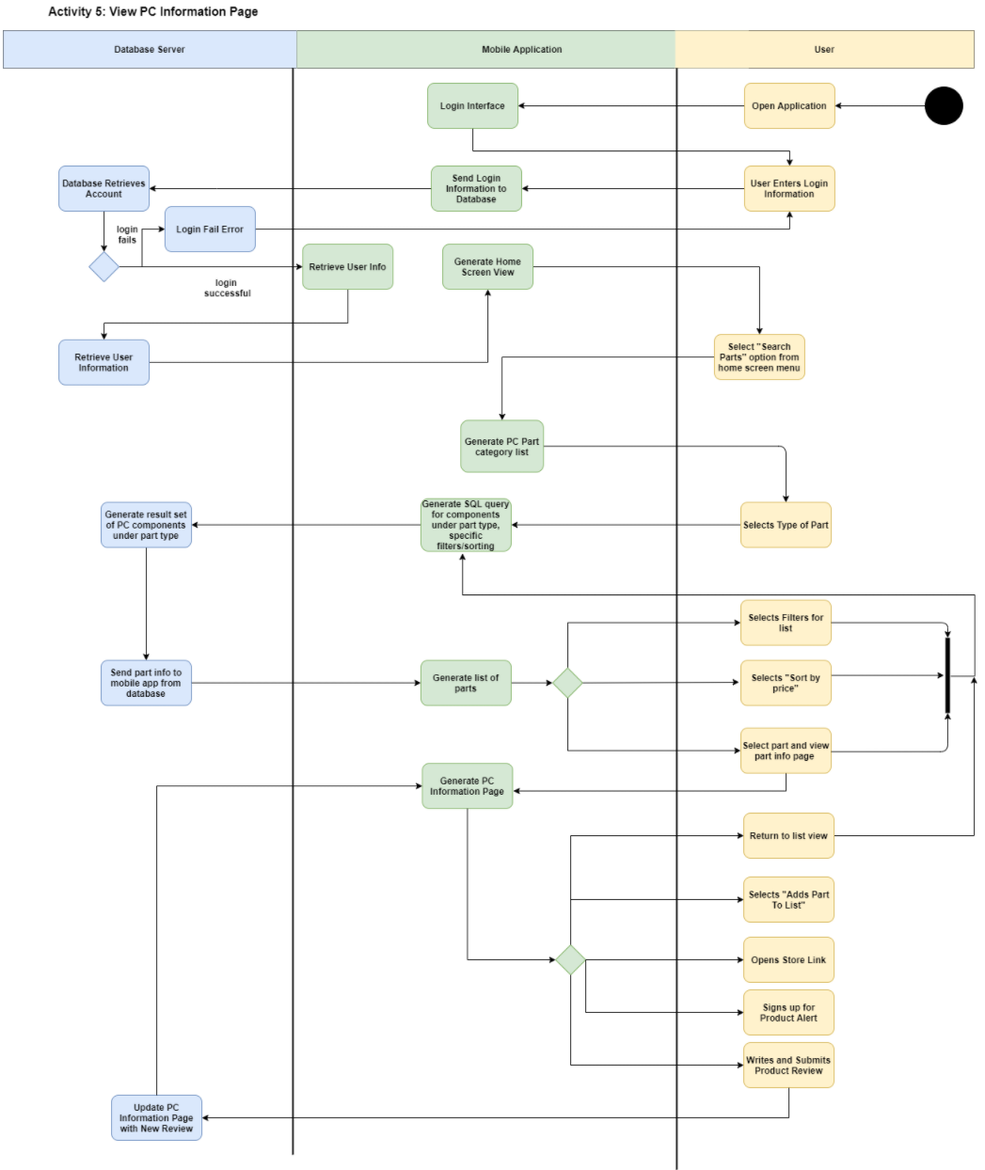

# **Architecture Specification**

## Class Diagram

The first class in the diagram is the Main Page. The main page is where the user can start the major functions of the application. The Search class allows the user to find and review pc components. The class generates a list of a specific type of pc part that can be filtered. The user can compare the parts, view more information in the PC info Page, view or create user reviews, and see other store prices. From the main page the user can also use the PC Builder. The PC Builder class is used to select the major components for a single PC. The class can calculate the total price, check compatibility between parts, and save the build list. The Suggest PC class will find prebuilt PCs based on the users desired performance and budget. The PC class presents a PC build and its parts. The PC Part class and its subclasses represent different pc components. These classes contain the store prices and details for specific components.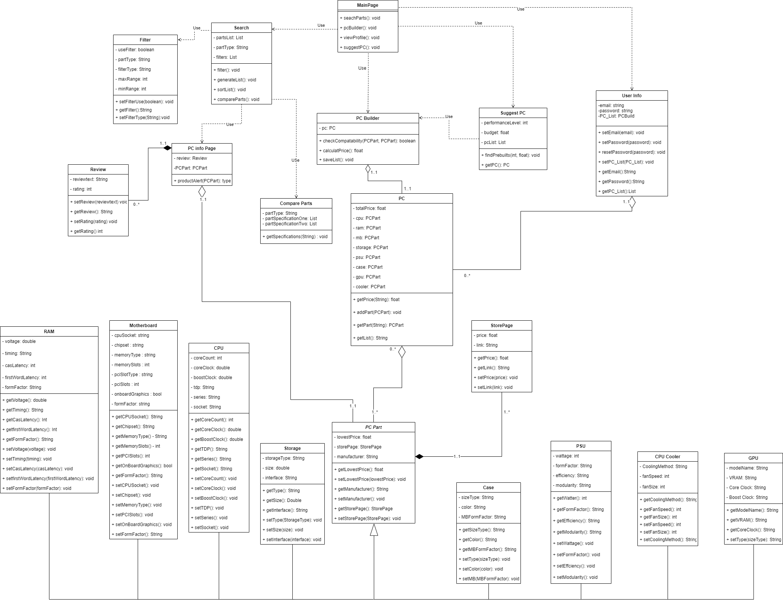

## Site Map

This diagram for QuickPC is a site map that displays the structure and pages of our application. This diagram helps with understanding the user interface of QuickPC. The diagram is also color coded describing the purpose and function of each box.Yellow boxes are the pages of our mobile application, purple boxes are sections of a page, and blue boxes are links to other pages that a user can arrive at.

